**Global Food Production Trends and Analysis (1961-2023)**

**Introduction:**

ABC Company undertook a comprehensive study of global food production trends from 1961 to 2023, leveraging Power BI for insightful visualizations. The analysis encompassed key agricultural commodities, revealing that total rice production amounted to 269 billion tonnes, while wheat production reached 282 billion tonnes. The study highlighted that tea production stood at 2 billion tonnes, with Africa emerging as the leading producer of green coffee. Additionally, the research underscored a steady rise in wheat, maize, and rice production over the years, with wheat showing the most significant increase.

The project also explored the production volumes of apples, avocados, bananas, and oranges by different regions, identifying Europe and Asia as significant contributors. Maize production demonstrated consistent growth, particularly from the late 1980s onward. The study further indicated that grapes had the highest total production among fruits at 43 billion tonnes, followed by apples, bananas, and oranges. This comprehensive analysis equips ABC Company with valuable insights to better understand global food production trends, aiding strategic decision-making in the agricultural sector.

**Scenario 1:** Sum of Rice Production (tonnes)

This section prominently displays the total global rice production, amounting to 269 billion tonnes over the period from 1961 to 2023. It highlights the significant volume of rice produced, emphasizing its importance as a staple food crop worldwide.

**Scenario 2:** Sum of Wheat Production (tonnes)

Highlighting the global wheat production, this section shows a total of 282 billion tonnes produced between 1961 and 2023. This underscores wheat's crucial role in global food security and its widespread cultivation.

**Scenario 3:** Sum of Tea Production (tonnes)

This section shows a gauge chart illustrating the total tea production, amounting to 2 billion tonnes. The visual emphasizes the scale of tea production compared to other major crops.

**Scenario 4:** Sum of Coffee, Green Production (tonnes) by Entity

A bar chart depicting the distribution of green coffee production among various entities. Africa, Asia, and America are leading producers, reflecting regional contributions to global coffee supply.

**Scenario 5:** Sum of Wheat, Maize, and Rice Production (tonnes) by Year

An area chart showing the annual production trends of wheat, maize, and rice from 1961 to 2023. It highlights the growth trajectories and fluctuations of these essential crops over the years.

**Scenario 6:** Sum of Apples, Avocados, Bananas, and Oranges Production (tonnes) by Entity

This stacked bar chart illustrates the production volumes of apples, avocados, bananas, and oranges by different entities. It highlights the diverse contributions to global fruit production.

**Scenario 7:** Sum of Maize Production (tonnes) by Year

A donut chart depicting the yearly maize production distribution across different years. It shows how maize production has evolved, with specific years highlighted for their significant contributions.

**Scenario 8:** Sum of Grapes, Apples, Bananas, and Oranges Production (tonnes)

This bar chart compares the total production volumes of grapes (43 billion tonnes), apples (39 billion tonnes), bananas (32 billion tonnes), and oranges (26 billion tonnes). It provides a comparative view of the global production scales of these popular fruits.

**Technical Architecture:**

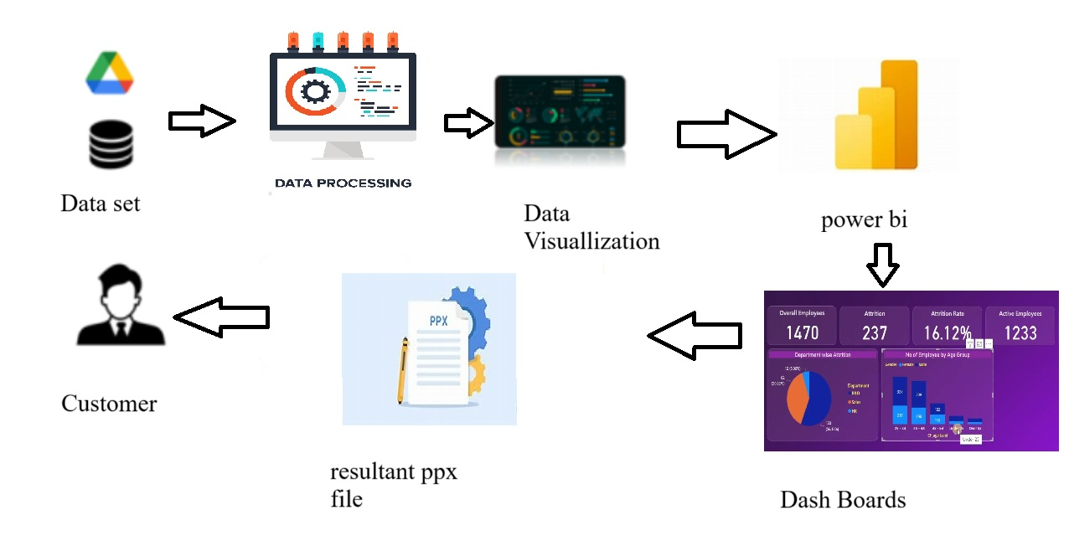

**Project Flow:**

To accomplish this, we have to complete all the activities listed below,

* Data Collection
* Collect the dataset,
* Connect Data with Power BI
* Data Preparation
* Prepare the Data for Visualization
* Data Visualizations
* Visualizations
* Dashboard
* Responsive and Design of Dashboard
* Report
* Report Creation
* Performance Testing
* Utilization of Data Filters
* No. of Calculation fields
* No. of Visualizations/Graphs
* Project Demonstration & Documentation
* Record explanation Video for project end to end solution
* Project Documentation-Step by step project development procedure.

**Milestone 1: Data Collection & Extracting from Database**

**Activity 1: Collect the dataset**

Please use the link to download the dataset**Click Here**

# Activity 1.1: Understand the data

Data contains all the meta information regarding the columns described in the CSV files Column Description of the Dataset:

* Entity: Represents the country or region where the food production data is recorded.
* Code: A unique identifier or code for each entity (country or region).
* Year: The specific year for which the data is recorded, ranging from 1961 to 2023.
* Apples_Production (tonnes): The total annual production of apples measured in tonnes.
* Avocados_Production (tonnes): The total annual production of avocados measured in tonnes.
* Bananas_Production (tonnes): The total annual production of bananas measured in tonnes.
* Coffee_green_Production (tonnes): The total annual production of green coffee measured in tonnes.
* Grapes_Production (tonnes): The total annual production of grapes measured in tonnes.
* Maize_Production (tonnes): The total annual production of maize measured in tonnes.
* Oranges_Production (tonnes): The total annual production of oranges measured in tonnes.
* Rice_Production (tonnes): The total annual production of rice measured in tonnes.
* Tea_Production (tonnes): The total annual production of tea measured in tonnes.
* Wheat_Production (tonnes): The total annual production of wheat measured in tonnes.

**Milestone 2: Data Preparation**

# Activity 2.1: Data Loading

The dataset is loaded into Power BI using "Get Data" → "Text/CSV" → "Load", ensuring all relevant columns are correctly imported for analysis**.**

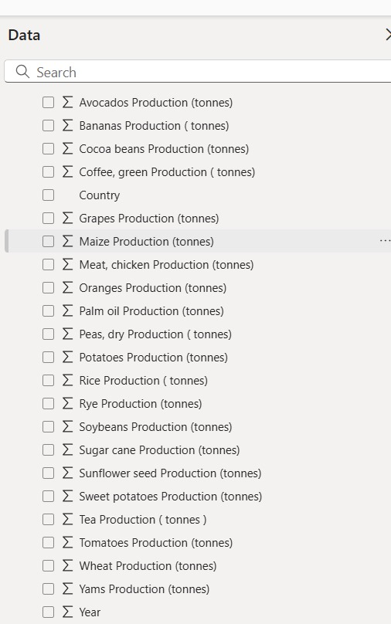

***Fig.1: Dataset***

# Activity 2.2: Data Cleaning Process

1. **Handling Missing Values:** 
   * Checked for any null or missing values in the dataset.
   * **Removed 0s in the Rice Production column** to eliminate inaccurate data points and ensure reliable analysis.
2. **Data Type Corrections:** 
   * Ensured that all numerical columns, such as rice, wheat, maize, and fruit production, were in the correct numeric format.
   * Adjusted any incorrect data types, such as changing text columns mistakenly stored as numbers.
3. **Formatting to Whole Numbers:** 
   * Since production data is measured in tonnes, values were formatted as whole numbers to ensure consistency.
   * Decimal places were removed to improve readability and maintain accurate reporting.

This cleaning process ensures that the dataset is accurate, structured, and ready for visualization in Power BI.

**Milestone 3: Data Visualization**

# Phase 1: Sum of Rice Production (tonnes)

* The global rice production reached **268.56 billion tonnes** from 1961 to 2023.
* The visual representation highlights the importance of rice as a staple food worldwide.
* The steady rise in rice production indicates increased agricultural efficiency, demand, and improved farming practices.
* The major rice-producing countries include China, India, Indonesia, and Bangladesh.

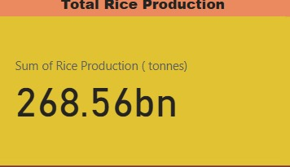

***Fig.2:Sum of Rice Production(tonnes)***

# Phase 2: Sum of Wheat Production (tonnes)

* Wheat is one of the most significant food grains, with **282 billion tonnes** produced over the analysed period.
* This production trend highlights wheat's role in global food security and widespread cultivation.
* Regions with the highest wheat production include China, India, the United States, and Russia.
* Wheat production has grown consistently, driven by technological advancements, better irrigation techniques, and increased demand.

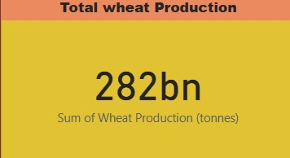

***Fig.3:Sum of Wheat Production(tonnes)***

# Phase 3: Sum of Tea Production (tonnes)

* The **total tea production** reached **2 billion tonnes** globally.
* The gauge chart highlights the scale of tea production relative to other crops.
* The top tea-producing countries include China, India, Kenya, and Sri Lanka.
* The demand for tea remains strong due to its cultural significance and increasing global consumption.

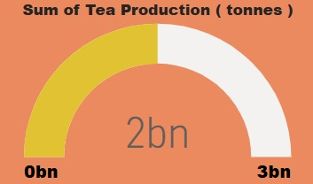

***Fig.4: Sum of Tea Production(tonnes)***

# Phase 4: Sum of Coffee, Green Production (tonnes) by Entity

* **Africa is the leading producer of green coffee**.
* The bar chart shows the distribution of coffee production across different continents.
* Other major coffee-producing regions include South America (Brazil, Colombia), Asia (Vietnam, Indonesia), and Central America.

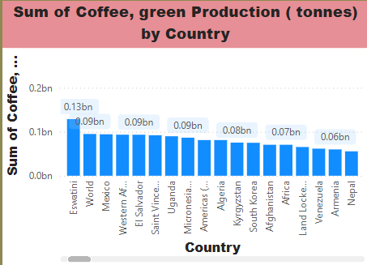

***Fig.5: Sum of Coffee, Green Production(tonnes)***

# Phase 5: Sum of Apples, Avocados, Bananas, and Oranges Production (tonnes) by Entity

* The **stacked bar chart** displays the production volumes of apples, avocados, bananas, and oranges.
* Europe and Asia are major contributors to global fruit production.
* **Key insights:**
* Armenia and Central Asia (FAO) show the highest apple production (blue).
* Belgium-Luxembourg (FAO) and Afghanistan have significant banana and orange production (orange and purple).
* Other regions, like India and Czechia, show moderate contributions across different fruits.

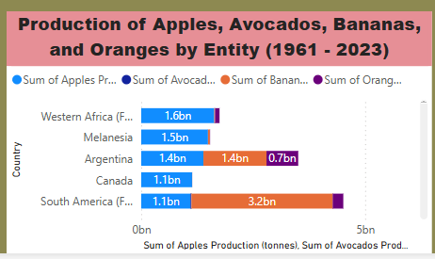

## Fig.6: Sum of Apples,Avacodes,Bananas Production(tonnes)

**Phase 5: Sum of Wheat, Maize, and Rice Production (tonnes) by Year** • The **area chart** illustrates annual production trends of these key crops.

• Observations:

* Wheat, maize, and rice have all experienced a steady increase. o Wheat has shown the most significant growth. o Maize production began accelerating in the late 1980s.
* The rise in production reflects global population growth, improved agricultural methods, and climate adaptation.

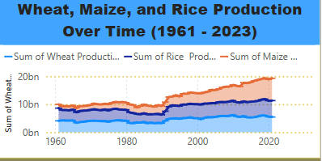

***Fig.7:Sum of Wheat,Maize,Rice Production(tonnes) by Year***

# Phase 7: Sum of Maize Production (tonnes) by Year

The donut chart illustrates the sum of maize production (tonnes) over different years. It shows a steady increase in maize production, with the highest contribution in the most recent years. The largest segment represents the highest recorded production, indicating significant growth in maize output over time.

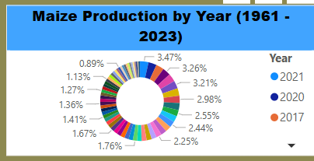

***Fig.8: Sum of Maize Production (tonnes) by Year***

# Phase 8: Sum of Grapes, Apples, Bananas, and Oranges Production (tonnes)

The **horizontal bar chart** represents the sum of fruit production (in tonnes) for grapes, apples, bananas, and oranges. Grapes have the highest production at 43 billion tonnes, followed by apples (39bn), bananas (32bn), and oranges (26bn). This visualization highlights the leading role of grapes and apples in overall fruit production.

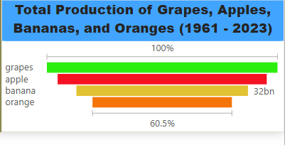

***Fig.9: Sum of Grapes, Apples, Bananas, and Oranges Production (tonnes)***

# Milestone 4: Dashboard

The dashboard presents an analysis of global food production trends (1961–2023) using various visualizations:

* **Total Production:** 
  + Rice: 268.56bn tonnes o Wheat: 282bn tonnes

o Tea: 2bn tonnes

* **Key Visualizations:**

o Coffee Production by Entity: Africa leads in coffee production.

o Wheat, Maize & Rice Production by Year: A steady increase over time.

o Fruit Production by Entity: Europe and Asia contribute significantly.

* + Maize Production by Year: Highest in 2006 (5bn tonnes), showing steady growth.

The dashboard effectively highlights food production trends across various commodities and regions.

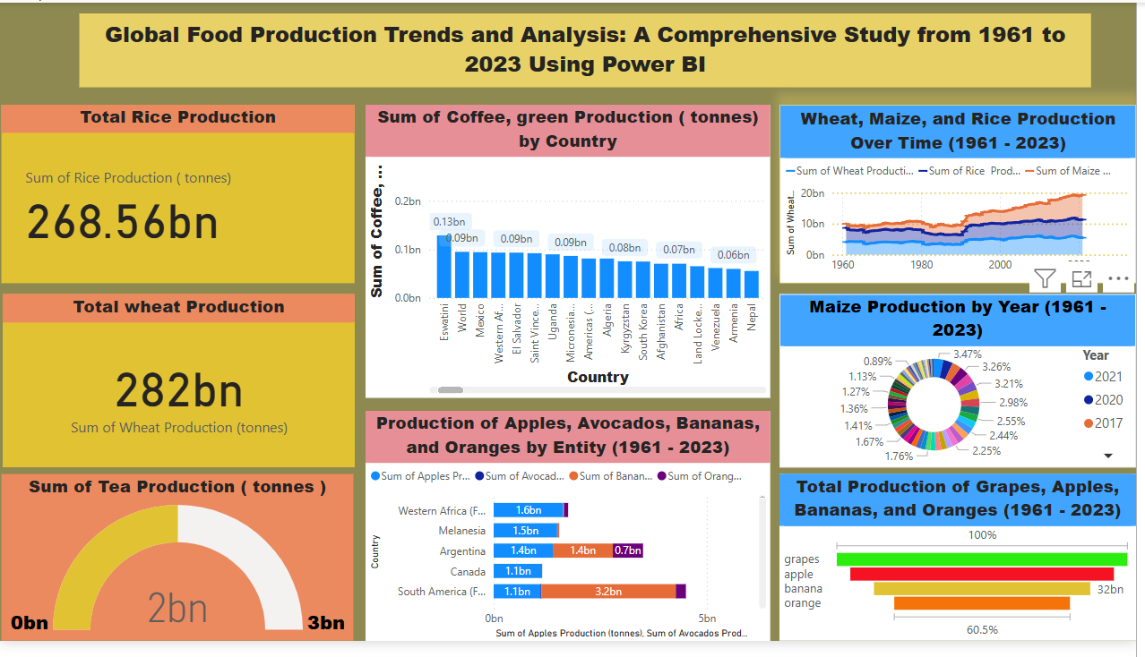

***Fig.10: Dashboard***

# Milestone 5: Report

This Power BI dashboard provides a detailed analysis of global food production trends from 1961 to 2023. It highlights key insights into major crop production, including rice, wheat, tea, coffee, maize, and fruits, using interactive visualizations like bar charts, pie charts, and trend lines. The dashboard effectively showcases production growth, regional contributions, and significant changes over time. Designed for clarity and ease of interpretation, it allows users to explore data trends efficiently and make informed decisions based on historical insights.

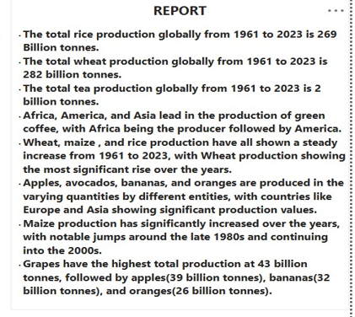

***Fig.11: Report***

**Milestone 6: Performance Testing**

# Amount of Data Loaded

"This refers to the total volume of data imported into Power BI for analysis. It represents the data successfully processed and available for visualizations, insights, and reporting. Managing data load efficiently ensures better performance and accurate results in the dashboard."



***Fig.12: Data Loaded***

# Utilization of Filters

Filters help refine data by selecting specific values or conditions, making analysis more focused and insightful. In this report, filters were applied to enhance data visualization and interpretation.

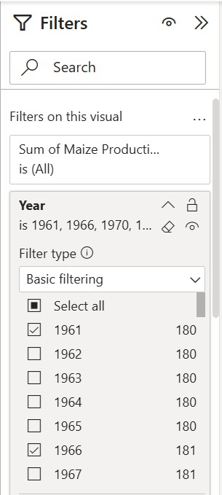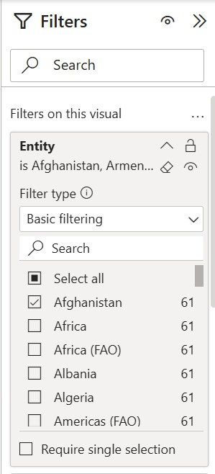

***Fig.13: Filters (Year, Country)***

**Milestone 7: Project Demonstration & Documentation**

**Activity 1: - Record explanation Video for the project's end-to-end solution**

[**https://drive.google.com/drive/folders/1rx5gbQ9_2AUJq43HVWnO_UTUmvGHyLPR?usp=sharing**](https://drive.google.com/drive/folders/1rx5gbQ9_2AUJq43HVWnO_UTUmvGHyLPR?usp=sharing)

**Activity 2: - Project Documentation-Step by step project development procedure**

<https://docs.google.com/document/d/1Rd7_kRnRY7ePPFw7eHPKqu20WAgiULCh/edit?usp=drive_link&ouid=102098702676369368355&rtpof=true&sd=true>